- Write a C program to perform matrix addition for 3*3 matrix.

#include <stdio.h>
int main() {
int matrix1[3][3], matrix2[3][3], result[3][3];
int i, j;
printf("Enter elements of the first 3x3 matrix:\n");
for (i = 0; i < 3; i++) {
for (j = 0; j < 3; j++) {
printf("Enter element a[%d][%d]: ", i, j);
scanf("%d", &matrix1[i][j]);
}
}
printf("\nEnter elements of the second 3x3 matrix:\n");
for (i = 0; i < 3; i++) {
for (j = 0; j < 3; j++) {
printf("Enter element b[%d][%d]: ", i, j);
scanf("%d", &matrix2[i][j]);
}
}
for (i = 0; i < 3; i++) {
for (j = 0; j < 3; j++) {
result[i][j] = matrix1[i][j] + matrix2[i][j];
}
}
printf("\nResultant matrix (Sum of the two matrices):\n");
for (i = 0; i < 3; i++) {
for (j = 0; j < 3; j++) {
printf("%d\t", result[i][j]);
}
printf("\n");
}

return 0;
}

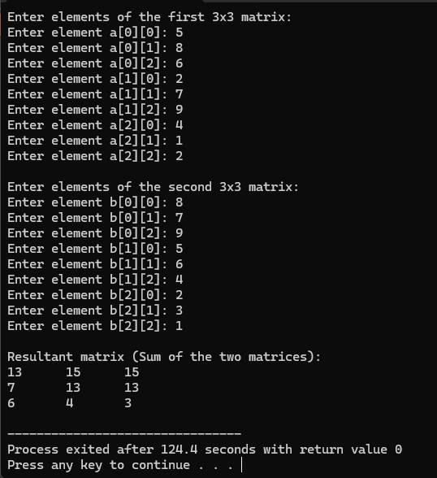

- Write a C program to perform matrix multiplication

#include <stdio.h>
int main() {
int r1, c1, r2, c2;
int i, j, k;

printf("Enter number of rows for First Matrix: ");
scanf("%d", &r1);
printf("Enter number of columns for First Matrix: ");
scanf("%d", &c1);
printf("Enter number of rows for Second Matrix: ");
scanf("%d", &r2);
printf("Enter number of columns for Second Matrix: ");
scanf("%d", &c2);
if (c1 != r2) {
printf("Matrices cannot be multiplied together. Number of columns of first matrix must equal number of rows of second matrix.\n");
return 0;
}
int m1[r1][c1];
int m2[r2][c2];
int result[r1][c2];
printf("Enter elements of the first matrix:\n");
for (i = 0; i < r1; i++) {
for (j = 0; j < c1; j++) {
printf("Enter element m1[%d][%d]: ", i, j);
scanf("%d", &m1[i][j]);
}
}
printf("Enter elements of the second matrix:\n");
for (i = 0; i < r2; i++) {
for (j = 0; j < c2; j++) {
printf("Enter element m2[%d][%d]: ", i, j);
scanf("%d", &m2[i][j]);
}
}
for (i = 0; i < r1; i++) {
for (j = 0; j < c2; j++) {
result[i][j] = 0;
}
}
for (i = 0; i < r1; i++) {
for (j = 0; j < c2; j++) {
for (k = 0; k < c1; k++) {
result[i][j] += m1[i][k] * m2[k][j];
}
}
}
printf("\nResultant Matrix:\n");
for (i = 0; i < r1; i++) {
for (j = 0; j < c2; j++) {
printf("%d\t", result[i][j]);
}
printf("\n");
}

return 0;
}

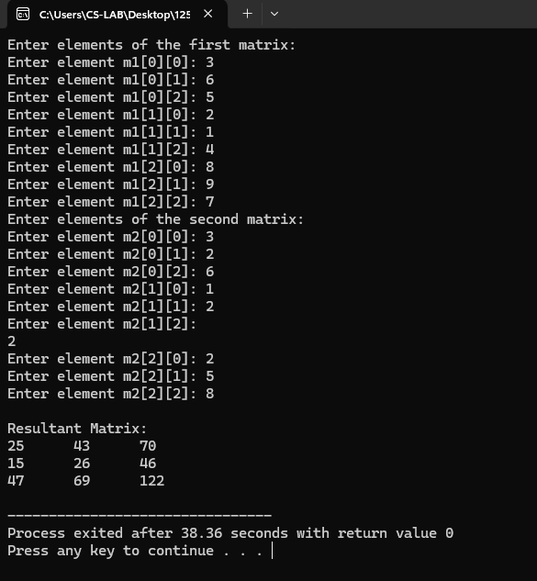

- Write a C program to create an array to store the basic salary of 5 employees. The program should: ● Calculate the Gross Salary for each employee using the formula: Gross Salary=Basic Salary+20%DA+10%HRA ● Display the Basic Salary and Gross Salary of each employee. ● Find and display the highest and lowest Gross Salary among all employees.
#include <stdio.h>
int main() {
float basicSalaries[5];
float grossSalaries[5];
int i;
printf("Enter the basic salary for 5 employees:\n");
for (i = 0; i < 5; i++) {
printf("Employee %d Basic Salary: ", i + 1);
scanf("%f", &basicSalaries[i]);
}
for (i = 0; i < 5; i++) {
float da = 0.20 * basicSalaries[i];
float hra = 0.10 * basicSalaries[i];
grossSalaries[i] = basicSalaries[i] + da + hra;
}
printf("\nEmployee Salary Details:\n");
printf("-----------------------------------\n");
printf("Employee | Basic Salary | Gross Salary\n");
printf("-----------------------------------\n");
for (i = 0; i < 5; i++) {
printf("%8d | %12.2f | %12.2f\n", i + 1, basicSalaries[i], grossSalaries[i]);
}
printf("-----------------------------------\n");
float highestGrossSalary = grossSalaries[0];
float lowestGrossSalary = grossSalaries[0];
for (i = 1; i < 5; i++) {
if (grossSalaries[i] > highestGrossSalary) {
highestGrossSalary = grossSalaries[i];
}
if (grossSalaries[i] < lowestGrossSalary) {
lowestGrossSalary = grossSalaries[i];
}
}
printf("\nHighest Gross Salary: %.2f\n", highestGrossSalary);
printf("Lowest Gross Salary: %.2f\n", lowestGrossSalary);
return 0;
}

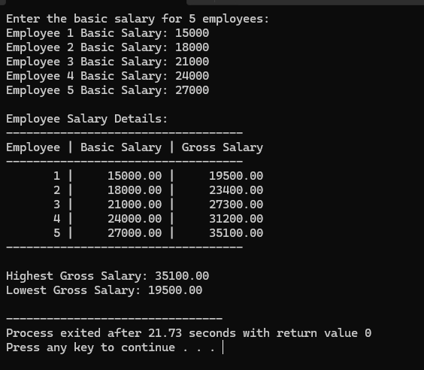

- Write a C program to create an array to store marks of 2 students in 3 subjects each. The program should: ● Input marks of each student. ● Calculate and display the Total Marks and Average Marks of each student. ● Also find and display the Highest and Lowest mark of each student.

#include <stdio.h>
int main() {
int marks[2][3];
int i, j;
int total_marks;
float average_marks;
int highest_mark, lowest_mark;
for (i = 0; i < 2; i++) {
printf("Enter marks for Student %d:\n", i + 1);
for (j = 0; j < 3; j++) {
printf(" Subject %d: ", j + 1);
scanf("%d", &marks[i][j]);
}
}
for (i = 0; i < 2; i++) {
total_marks = 0;
highest_mark = marks[i][0];
lowest_mark = marks[i][0];

for (j = 0; j < 3; j++) {
total_marks += marks[i][j];

if (marks[i][j] > highest_mark) {
highest_mark = marks[i][j];
}
if (marks[i][j] < lowest_mark) {
lowest_mark = marks[i][j];
}
}

average_marks = (float)total_marks / 3;

printf("\n--- Results for Student %d ---\n", i + 1);
printf("Total Marks: %d\n", total_marks);
printf("Average Marks: %.2f\n", average_marks);
printf("Highest Mark: %d\n", highest_mark);
printf("Lowest Mark: %d\n", lowest_mark);
}
return 0;
}
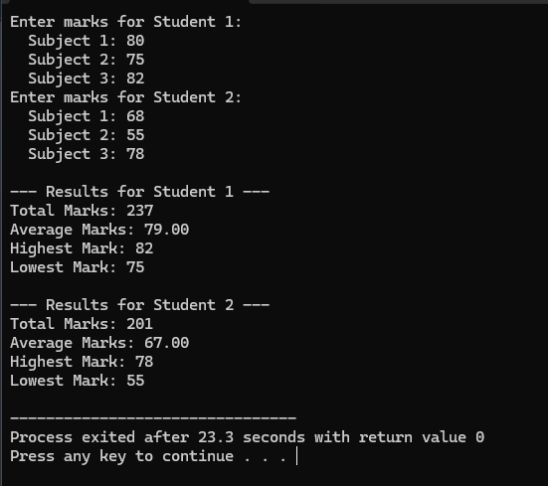

- Write a C program to create a 2D array to store marks of 5 students in 3 subjects each. The program should: ● Input marks of all students.

#include <stdio.h>
int main() {
int marks[5][3];
int i, j;
printf("Enter the marks for 5 students in 3 subjects:\n");
for (i = 0; i < 5; i++) {
printf("For Student %d:\n", i + 1);
for (j = 0; j < 3; j++) {
printf(" Enter marks for Subject %d: ", j + 1);
scanf("%d", &marks[i][j]);
}
}
printf("\nMarks entered:\n");
for (i = 0; i < 5; i++) {
printf("Student %d: ", i + 1);
for (j = 0; j < 3; j++) {
printf("%d ", marks[i][j]);
}
printf("\n");
}
return 0;
}

